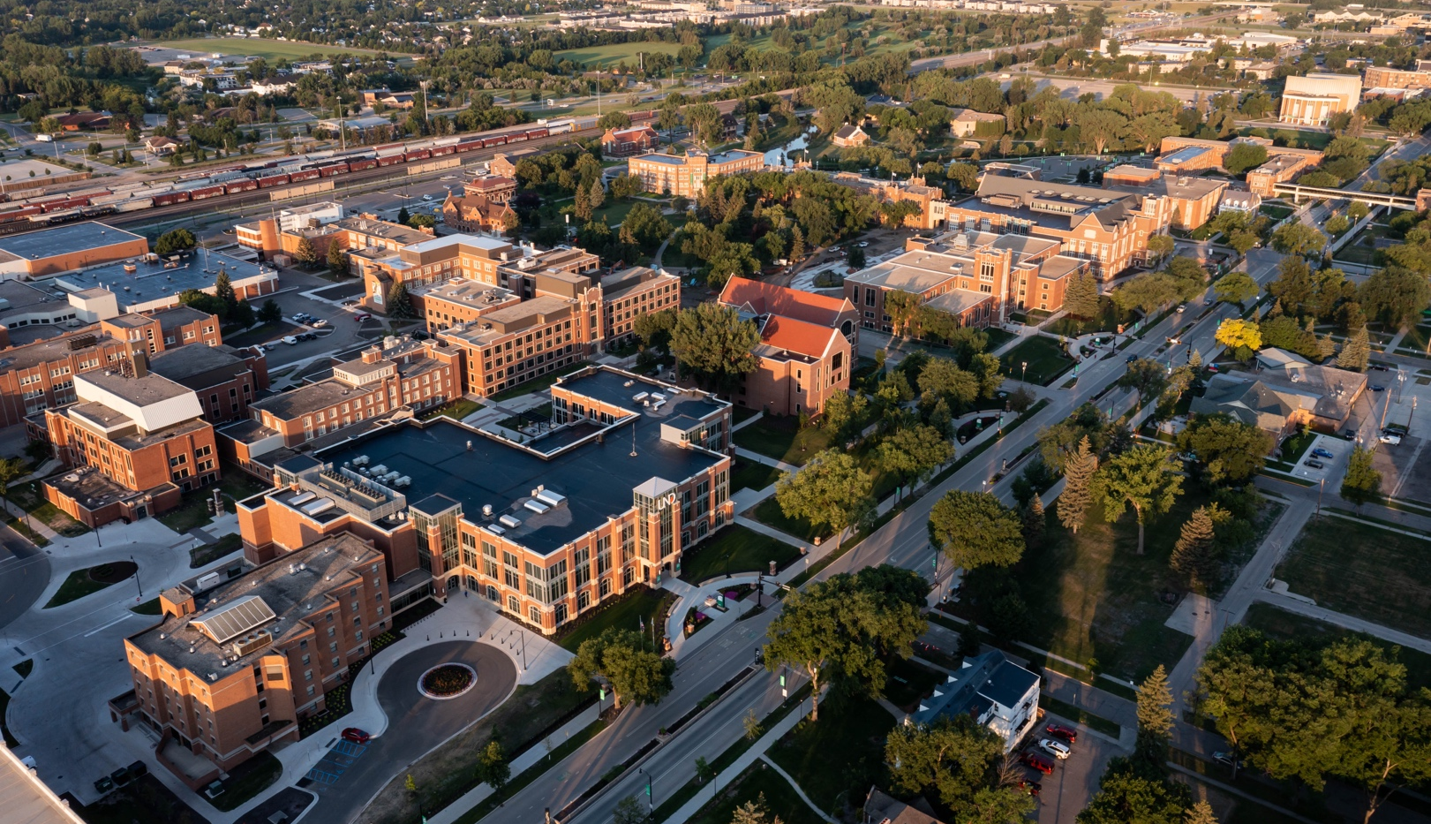

Word template
  - Use this guide to ensure accessibility and brand consistency.

Typography
- Use the Styles group on the Home tab. Do not alter styles.
- This document contains license-free branded typefaces: Oswald Medium, Nimbus Roman No9L and Arial. If these fonts are not already installed on your computer, they are available for download at Font Squirrel.

Photos
To replace a placeholder photo, right click on the photo and select Change Picture. If you don’t have your own photos, you can select a photo featuring a wide range of UND programs, activities and locations from our online public photo library.

Accessibility
Visit TTaDA’s page on Accessible Content for Microsoft Word.

