
Process: Non-Employee Refund/Reimbursement Form:

The following process may be used to initiate a one-time non-taxable payment (commonly known as a ‘single payment voucher’) to an entity/individual. Use of this process does not require the creation of a supplier record in UND Marketplace and offers a more customer-friendly process for payment. While each payment must be ‘’one-time”, there are no limits on how many unique/one-time, non-taxable payments may be made to an entity via this process. If the entity is already registered as a supplier in UND Marketplace, you may still opt to use this process for any non-taxable payment to the entity.

Examples of non-taxable payments that can utilize this process:
- Refund of a previously paid expense, such as refunds for canceled conferences, event registrations, ticket purchases, or funds mistakenly deposited to UND.
- Reimbursement of approved travel or business expenses for a non-employee (e.g., candidates for open positions, UND students).

Examples of payments that cannot utilize this process:
- Payments related to the university receiving goods or services
- Payments to research participants
- Stipends
- Refunds of student account charges (including tuition and fees, housing, etc.)
- Payments of prizes and awards

Note: The payments issued as a result of this process will be made via check only. Checks are mailed once weekly (generally Friday) by Procurement & Payment Services. If payment via ACH/direct deposit is required/desired, the standard UND supplier setup (including W9 and UND ACH Form) and payment request processes must be followed.

A description and justification of why the money is being paid out must be provided and backup documentation supporting the payment (e.g., the Non-Employee/Student Travel Expense Worksheet) must be attached to this form.

Procedure: Non-Employee Refund/Reimbursement Form:

NOTE: Fill out all required information, indicated by the *, before progressing. If you attempt to go back after going to cart, your information will be erased. You will then have to start completely over.

- SECTION: ‘Remittance Information’
  - Supplier: ‘UND REFUNDS REIMBURSEMENTS’
  - Include the full name, address, email, and phone contact information of the recipient of the one-time payment. (This is where the check will be mailed).

- SECTION: ‘Invoice Information’

  - Because there is not an actual invoice from the payment recipient, in this section enter EITHER the original transaction information (if this is a refund), or the receipt/per diem information (if this is a non-employee expense reimbursement).
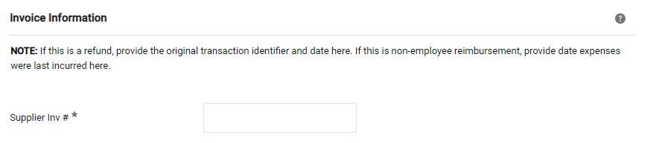
- SECTION: ‘Invoice date’
  - Date that the purchase occurred/date from the receipt, or the date of the original transaction being refunded.

Note: For multiple receipts from different dates, please include information in ’Payment Justification/Description’ and
include attachments of all receipts in the Attachments section..

- SECTION: ‘Attachments’
  - Include all required documentation here as follows:
    - Refunds: provide documentation of the original transaction (such as screen shots from Peoplesoft or the finance system of record).
    - Non-employee reimbursement: provide backup documents, including the Non-Employee Travel Expense Worksheet, copies of receipts, or per diem information.
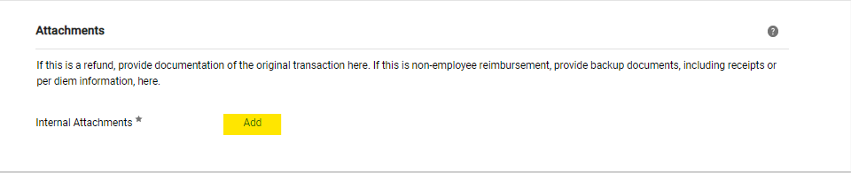

- SECTION: ‘Items’
  - Itemize each transaction as it shows on the receipt or original transaction detail.

  - Once finished and all information is entered – Select the button ‘Add and go to Cart.’
c. 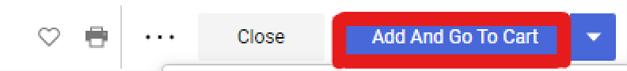
d. Another option is selecting the drop-down arrow to the side and selecting ‘Add to New Cart” - this will allow you
to continue if you have items in the current cart. This keeps the two separate and allows you to continue with minimal issues.

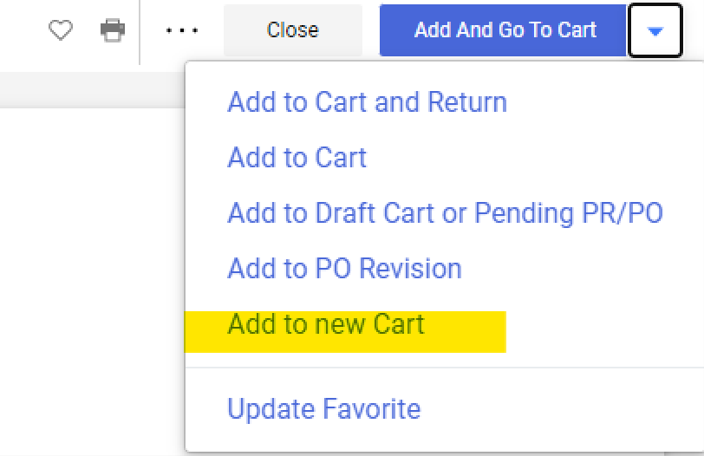
i.
NOTE: Fill out all required information, indicated by the *, before progressing. If you attempt to go back after going to cart, your information will be erased. You will then have to start completely over.

- The next screen is the shopping cart. Ensure that the total amount is correct.
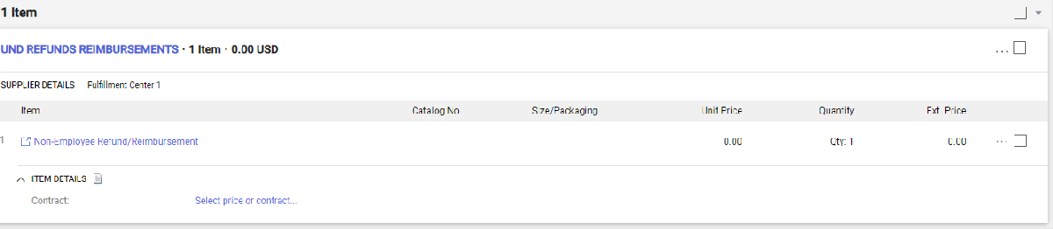

- If this amount is correct, UND Marketplace ‘Shoppers’ must ‘Assign Cart’ (Step 8) to who will process the requisition; those
with the Requester role in UND Marketplace may ‘Proceed to Checkout’ (Step 9) to submit the request.
a. 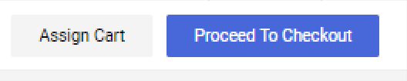
- Shoppers – To assign a cart

  - Select ‘Assign Cart’ then on the pop up, hit ‘Search’, find the appropriate contact, select their user name and then ‘Assign’ it to them.
  - It is recommended to add a note, so the assignee know any pertinent information needed to complete the requisition.
c. 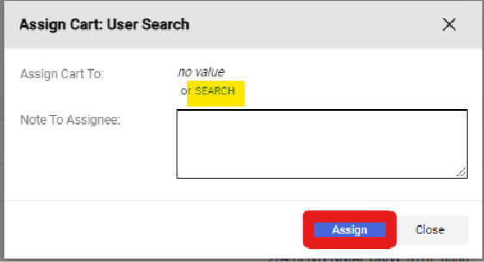

- Requesters – After you Proceed to Checkout
  - Fill out the business purpose under the general information. The IT Non-Standard and Software name are not required fields, and the form will let you proceed without any text in those fields.
i. 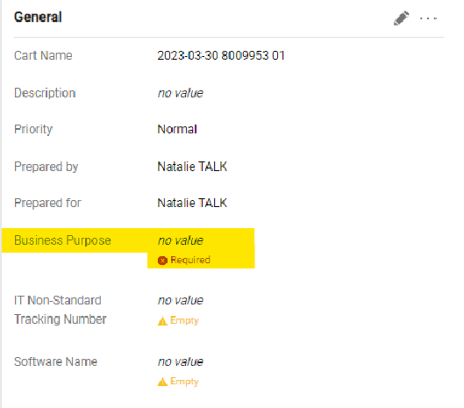
  - Shipping information
    - Add the shipping address of the department who is paying.
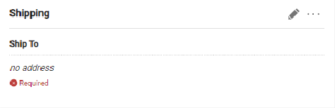

  - Accounting Codes: Account, Department, Fund-Dept as appropriate to pay for the refund or non-employee reimbursement.

- Double check that everything is accurate and filled out – then ‘Place Requisition.’ Notifications will be received within UND
Marketplace on the status of the Non-Employee Refund/Reimbursement Form as it progresses through the workflow.

As always – reach out to Procurement and Payment Services with any questions, concerns, or clarification needed. If you have suggestions for how to better these instructions, please submit those to und.pps@und.edu as well.

