How to Self-Enroll in Course
Purchasing Card (P-Card) training is required for all new P-Card holders; training must be completed before receiving a P-Card. In this training, you will learn the requirements and responsibilities for making purchases using your P-Card.

How to Access the Course
Before you begin, please know that Chrome is the recommended browser to use. You can make sure Chrome is up to date by visiting this website:
https://help.blackboard.com/Learn/Administrator/Hosting/Release_Notes/Browser_Support/Browser_Checker

- To access the Data Privacy course, log into Blackboard: https://blackboard.ndus.edu
(you can also use your campus’ Blackboard URL.)
- Select the Courses link on the left
- Locate and select the Course Catalogue link in the upper right
- In the search box type “NDUS Purchasing Card” and select Go:
- Hover your mouse over the course name “NDUS-PCard-2024” to reveal a drop-down list. Select Enroll:
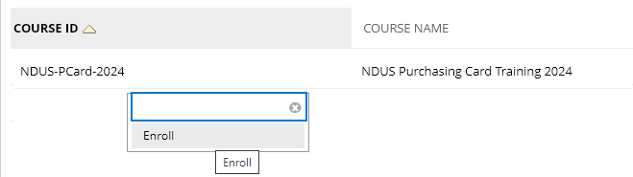
- Enter the enrollment key “NDUSPCard2024”. This key is case-sensitive and there should be no spaces.
- Select Submit, Ok. This will bring you into the course. If you need to leave the training, you will find this course in the Courses link in Blackboard.

If you have questions on the course itself or run into any problems, please contact your campus’ Blackboard Administrator. Your campus Help Desk can direct you on who that person is.

