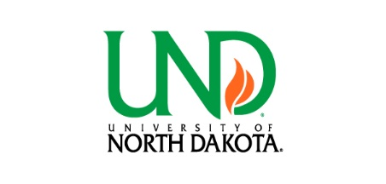PREVIOUS RETIREMENT PARTICIPATION VERIFICATION of
NDPERS, NDTFFR OR TIAA
Name: | Last Four SSN:
Daytime Phone: | Current Date of Hire:
Employees shall be given credit for the years of service during which they accrued employer-sponsored retirement benefits under the North Dakota Public Employees Retirement System, North Dakota Teachers’ Fund for Retirement, and/or as part of an employer matched TIAA. Credit for TIAA years of service shall also include credit at other institutions, including out-of-state institutions, provided employee has a current TIAA contract (i.e., was not repurchased). These plans do not qualify if you withdrew funds from the employer-sponsored plan or if they were plans with employee contributions only, such as supplemental 403b or 457b.
Please indicate the plan you participated in previously, follow those instructions and complete the signature. If eligible, credit for prior service will start on the next possible payroll after receipt of this form.
☐ TIAA: please forward this form to your prior employer for verification of funds in the account.
- If yes, was any of the previous service from UND: Yes ____ No ____
☐ NDPERS Retirement or ☐ NDTFFR: please return this form to the UND HR/Payroll Office.
☐ None
I authorize NDPERS, NDTFFR, my prior employer, or TIAA to release my retirement account information for purposes relating to membership and benefits determination to UND. (One form to each employer)
_________________________________ _________________________________
Employee Signature Date
Prior Employer:
I hereby certify the employee named above, participated in one of the following employer sponsored plans:
☐TIAA ☐ NDPERS ☐ NDTFFR Employer contributions were made from: ____________ to ____________
MM/DD/YY MM/DD/YY
Funds are: ☐ Intact ☐ Disbursed
_________________________________ _________________________________
Signature of Representative Name of Educational Institution
_________________________________ _________________________________
Printed Name Phone Number
_________________________________ _________________________________
Title Fax or email
Please return form to: und.payrollbenefits@und.edu or Fax 701 777-4721 3/2026

