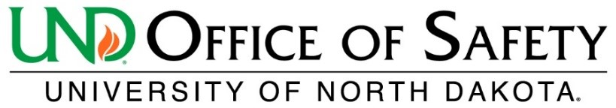
Use of Tax-Free Alcohol Agreement
Tax-free alcohol is regulated by the Alcohol and Tobacco Tax and Trade Bureau (TTB) per the Code of Federal Regulations, Title 27, Part 22. Laboratories which purchase tax-free alcohol under UND’s Industrial Alcohol user permit must meet federal requirements to maintain the permit and avoid penalties.

Researchers who order and use tax-free alcohol MUST agree to comply with the following requirements:

Initials | TTB Requirements
 | Tax-free ethanol will be used exclusively for education, scientific research, or medicinal purposes.
 | Tax-free ethanol containers must be secured at all times by locking the flammable storage cabinet or by locking the main lab door when the lab is unoccupied.
 | All mixtures and dilutions made using tax-free alcohol must be labeled appropriately to ensure material is not inadvertently transported off premises.
 | An inventory log is required. Inventory records include the date of receipt and withdrawal, amount withdrawn, person withdrawing, purpose for withdrawal, and remaining quantity.
 | UND Office of Safety will request inventory records in June and December annually to comply with biannual record-keeping requirements.
 | Tax-free ethanol may not be transferred outside UND property for any reason. No exceptions.
 | Records of purchase, receipt, use logs, or loss will be maintained for a period of three years by the PI or designee.
 | Use records and storage areas are subject to inspection at any time by representatives of the UND Office of Safety and/or agents of the TTB.

Printed Name ______________________________________________________
Signature__________________________________________________________ Date_________________
Department _______________________________________________________

Submit this form to the UND Lab & Research Safety Officer. kristie.adams@UND.edu

