General Storage Requirements
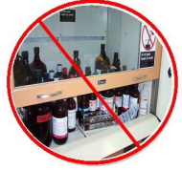
- Always review a chemical’s SDS for proper storage procedures.
- Do not store glass chemical containers on the floor (without secondary containment) or window ledges.
- Chemical storage areas should be well lit, appropriately ventilated and kept away from aisles, exits, and heat.
- Minimize storage on the lab bench, in fume hoods, and other work areas.
- Use a first-in, first-out system (oldest chemicals first); to avoid degradation of older chemicals and their containers.
- Inspect stored chemicals often for expiration, deterioration and chemical integrity.
Storage Shelves/Cabinets
- Ensure chemical storage shelves are securely fastened to the wall and have lips or other suitable methods to prevent bottles from falling.
- Avoid storing all chemicals above shoulder height. Large containers (1 gallon or larger), liquids, and corrosive materials should be stored no higher than eye level.
- Do not overcrowd shelves.
- Flammables (in excess of 10 gal) must be stored in a flammable storage cabinet.
- Label chemical storage cabinets according to the type of chemical family or hazard classification found there (Acid Storage, Solvent Storage, etc.).
Storage in Refrigerators and Freezers
- Never store chemicals in office, domestic, or personal refrigerators; food and chemicals should never be stored together.
- When storing flammables in refrigerator, use an approved explosion proof or flammable storage refrigerator only.
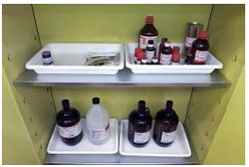
- Label all refrigerator/freezers according to intended use.
- Frequently inventory materials stored in refrigerator/freezers and defrost occasionally to prevent chemicals from becoming trapped in ice formations.
Secondary Containment
- Use secondary containment, such as polyethylene or stainless-steel trays, to separate incompatible chemicals stored in the same area and to provide spill containment.
- Provide secondary containers for storage of solvents and concentrated acids and bases.
- Use secondary containers during storage of all hazardous chemicals on the floor.
Storage of Hazardous Waste
- Minimize storage of hazardous waste.
- Store hazardous waste using the same guidelines as you would for storing chemical containers; use secondary containment, ensure the container is closed when not in use, and ensure proper labeling of the waste.
- If you no longer need a chemical, rather than keeping it stored, dispose of it properly (e.g. as hazardous waste) or follow the chemical reuse guidelines.
- Maximum storage times:
  - When storing untreated chemicals that degrade to unstable forms (e.g. peroxide formers such as ethyl ether), limit maximum storage time to one year from purchase or six months from first use. Note date received/date opened on such materials.
  - For other hazardous chemicals, use manufacturer’s recommended storage time (if there is one) or other indications of degradation (e.g. discoloring of liquids).
- Expired chemicals should not be stored or used in laboratories and should be relinquished to Office of Safety for disposal.
Segregating Hazardous Chemicals
Store chemicals by hazard classification; avoid storing chemicals alphabetically unless they are compatible or already separated into appropriate hazard classes - this ensures that incompatible chemicals are segregated.
Accidental contact between incompatible chemicals can result in a fire, an explosion, the formation of highly toxic and/or flammable substances, or other potentially harmful reactions. If incompatible chemicals must be stored in the same cabinet, be sure to provide physical segregation (secondary containment).

Class of Chemical | Recommended Storage Method | Examples | Incompatible  (See SDS in all Cases)
Corrosive Organic Acids  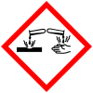 | - Use ventilated safety cabinet  - Store using protected shelving with secondary containment  - Keep away from water  - DO NOT store under sink or on metal shelving | - Acetic Acid  - Butyric Acid  - Glacial Acetic Acid  - Picric Acid  - Propionic Acid  - Trifluoroacetic Acid | - Bases  - Cyanides  - Flammable Liquids  - Flammable Solids  - Inorganic Acids  - Oxidizers  - Poisons or Toxins  - Sulfides
Corrosive Inorganic Acids | - Concentrated Nitric (≥68%) and Sulfuric Acids (≥93%) should be stored in secondary containers  - Use a safety cabinet labeled “Acid” or on protected shelving using secondary containment  - DO NOT store under sink or on metal shelving  - Store Hydrofluoric Acid where accessible only by authorized personnel  - Use plastic containers and secondary containment — DO NOT store in glass  - Consult Division of Environmental Protection (DEP) for assistance | - Chromic Acid  - Hydrochloric Acid  - Hydrofluoric Acid  - Nitric Acid  - Perchloric Acid  - Phosphoric Acid  - Sulfuric Acid | - Bases  - Cyanides  - Flammable Liquids  - Flammable Solids  - Organic Acids  - Oxidizers  - Poisons or Toxins  - Sulphides
Caustic and Corrosive Organic Bases | - Use separate cabinet — ventilated corrosive cabinet recommended or area with spill tray  - Keep away from potential water sources  - DO NOT store under sink | - Hydroxylamine  - Tetramethylethylamine  - Diamine  - Triethylamine | - Acids  - Flammable Liquids  - Flammable Solids  - Inorganic Bases  - Oxidizers  - Poisons or Toxins
Caustic and Corrosive Inorganic Bases | - Use separate cabinet — ventilated safety cabinet recommended or area with spill tray  - Keep away from potential water sources  - DO NOT store under sink  - Use labeled polyethylene containers for solutions of inorganic hydroxides | - Ammonium Hydroxide  - Calcium Hydroxide  - Potassium Hydroxide  - Sodium Hydroxide | - Acids  - Flammable Liquids  - Flammable Solids  - Organic Bases  - Oxidizers  - Poisons or Toxins
Flammable Solids  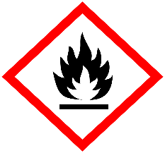 | - Store in a dry, cool area and away from oxidizers and corrosives | - Carbon  - Charcoal  - Magnesium  - Paraformaldehyde  - Phosphorus | - Acids  - Bases  - Oxidizers  - Poisons or Toxins
Flammable Liquids | - Use flammable safety cabinet or flammable and explosion proof refrigerators  - Record receipt and open dates for any peroxide-forming chemicals | - Acetone  - Benzene  - Diethyl Ether  - Ethanol  - Ethyl Acetate  - Glacial Acetic Acid  - Methanol  - Tetrahydrofuran  - Toluene  - Xylene | - Acids  - Bases  - Oxidizers  - Poisons or Toxins  - Reactives
Poisons or Toxins  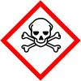 | - Store in a dark, dry, ventilated, and cool area  - Use unbreakable chemically resistant secondary container (polyethylene)  - Store volatile toxins with evaporation rate above 1.0 - (ether =1.0) in a flammable cabinet  - Store non-volatile liquid poisons in a refrigerator or cabinet  - Store amounts less than 1 L in above bench level cabinets ONLY when the cabinet has sliding doors  - Store Hydrofluoric Acid where accessible only by authorized personnel  - Use plastic containers and secondary containment — DO NOT store in glass | - Acrylamide  - Chloroform  - Cyanides  - Ethidium Bromide  - Heavy Metal Compounds: Cadmium, Mercury, Osmium, Oxalic Acid, Phenol, Formic Acid, Formamide  - Hydrofluoric Acid  - Sodium Azide | - Acids  - Bases  - Corrosives  - Flammable Liquids  - Oxidizers  - Reactives
Explosives  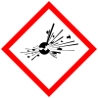 | - Secure and store away from other chemicals  - Keep away from friction or shock | - Ammonium Nitrate  - Benzoyl Peroxide  - Diazoisbutylnitrile  - Nitro Urea  - Picric Acid  - Trinitroaniline  - Trinitrobenzene  - Trinitrobenzoic Acid  - Trinitrophenol  - Trinitrotoluene  - Urea Nitrate | - Consult Safety Data Sheet (SDS)
Oxidizers  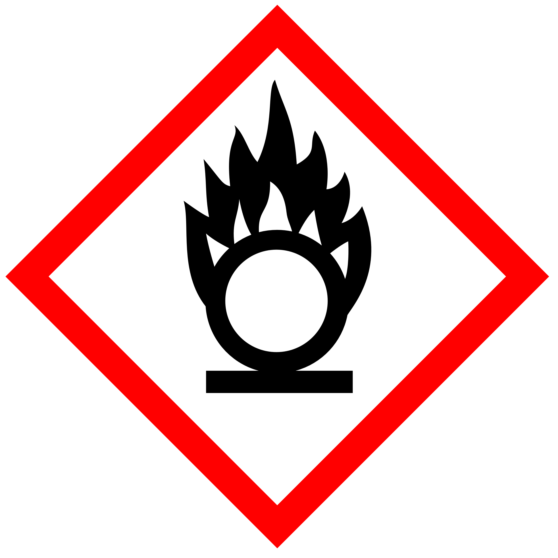 | - Store separately from combustibles and flammable materials  - Use secondary containment | - Bromates  - Chlorates  - Ethyl Acetate  - Ferric Chloride  - Iodine  - Nitrates  - Perchlorates  - Permanganates  - Peroxides  - Sodium Hypochlorite  - Superoxides | - Combustibles  - Flammables  - Organic Materials  - Reducing Agents
Peroxide Formers | - Keep away from light and heat  - Store in airtight bottles  - Avoid containers with loose-fitting lids and ground glass stoppers  - Record receipt and open dates for any peroxide-forming chemicals  - Crystallization, discoloration, and formation or deposition of layers are signs of shock sensitivity — DO NOT use or move such containers  - DO NOT handle old or expired containers of peroxide-forming chemicals or reactives. | - Acetals  - Acrylonitrile  - Aldehydes  - Butylated Hydroxytoluene  - Compounds  - Dienes Tetrahydrofuran  - Diethyl Ether  - Dioxane  - Isopropyl Ether  - Ketals, including secondary Alkyl groups  - Vinyl and Vinylidene | - Consult Safety Data Sheet (SDS)
Water Reactive | - Store in a dry, cool area  - DO NOT store under sink  - Keep away from potential spray from fire sprinklers and other water sources  - Label the storage area for water-reactive storage | - Alkali Metal Salts | - Aqueous Solutions  - Oxidizers
Compressed Gases – Flammable  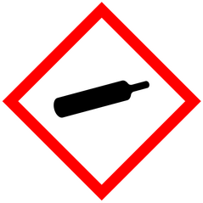 | - Store in well-ventilated area  - Store away from oxidizers, open flames, sparks, and other sources of heat ignition  - Keep out of direct sunlight if storing outdoors where ambient temperatures exceed 125°F or 51.7°C  - Use a non-sparking wrench to attach regulators and other connections  - Install a flame and flash arrestor at the regulator outlet flow valve  - Post NO SMOKING signs around storage areas and entrances  - Use a chemical fume hood to handle flammable compressed gases | - Acetylene  - Arsine  - Butane  - Ethane  - Germane  - Hydrogen  - Methane  - Propane  - Silane | - Oxidizers  - Toxic Compressed Gases
Compressed Gases – Oxidizing | - Store oxidizers separately from flammable gas containers and combustible materials  - Minimum separation requirement is 20 ft. or 5 ft. for a noncombustible barrier with a minimum fire resistance rating of 30 minutes  - Equipment used for Oxygen and Nitrous Oxide with Oxygen-Compatible materials should be cleaned with materials free from oils, greases, and other contaminants  - Handle Fluorine in specially passivated containers and associated equipment | - Chlorine  - Fluorine  - Gas mixtures containing Oxygen levels higher than atmospheric concentrations  - Nitrogen Oxides  - Oxygen | - Flammable Compressed Gases  - Toxic Compressed Gases
Compressed Gases – Toxic | - Use a chemical fume hood when handling toxic compressed gases  - Use a gas cabinet, exhausted enclosure, or gas room for indoor storage or use of toxic compressed gases  - Refer to SDS information for additional guidance  - Contact Division of Occupational Health and Safety (DOHS) to determine if a failsafe valve or continuous monitoring for toxic gas may be required | - Carbon Monoxide  - Hydrogen Chloride  - Hydrogen Sulfide  - Nitrogen Dioxide | - Flammable Compressed Gases  - Oxidizing Compressed Gases
General Stock Chemicals | - Storage should be on shelves or benches with glass doors  - Store below eye level and with similar chemicals | - Agar  - Most Non-Reactive Salts  - Salt Buffer  - Sodium Bicarbonate  - Sodium Chloride | - Consult SDS

