Fume Hood Safety
The Golden Rules…

 | Make sure the hood is ON and working. Verify the air flow reading.
Keep the sash closed except when performing work. |  | 
 | Work 6 to 8 inches inside the plane of the sash.
Do not block the airflow through the baffles or through the baffle exhaust slots.
 | Raise equipment up off the hood deck (Do NOT use wood).
Remove unnecessary items. Don’t use the hood for storage.
 | Wear proper personal protective equipment (PPE) and move arms slowly in and out of the hood.
Never place your head inside of the fume hood. |  | 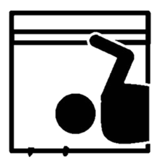
 | ALWAYS CLEAN UP AFTER YOU ARE DONE IN THE HOOD!
UND Office of Safety 701.777.3341 UND.safety@UND.edu

