LABORATORY HAZARD ☐ Research Lab ☐ Teaching Lab
SAFETY INFORMATION CARD ☐ Storage
Department |  |  |  |  | Click here to enter text. |  |  |  |  |  |  |  | Building & Room | Click or tap here to enter text.
CAUTION  -HAZARDS MAY BE PRESENT- |  |  |  |  |  |  |  |  |  |  | 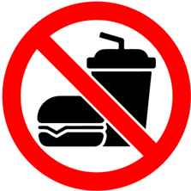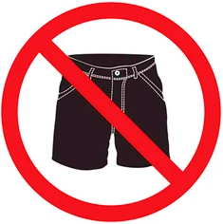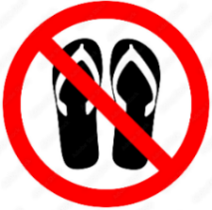  No Eating or No Shorts/ No Sandals/  Drinking Short Skirts Open-toed Shoes
Contact |  |  | Click or tap here to enter text. |  |  |  |  |  |  |  |  |  |  |  |  | Phone | Click here to enter
Contact |  |  | Click or tap here to enter text. |  |  |  |  |  |  |  |  |  |  |  |  | Phone | Click here to enter
Contact |  |  | Click or tap here to enter text. |  |  |  |  |  |  |  |  |  |  |  |  | Phone | Click here to enter
Contact |  |  | Click or tap here to enter text. |  |  |  |  |  |  |  |  |  |  |  |  | Phone | Click here to enter
Contact |  |  | Click or tap here to enter text. |  |  |  |  |  |  |  |  |  |  |  |  | Phone | Click here to enter
Routine Access Information:
☐ Housekeeping and Support Services may enter to clean floors and empty trash only
☐ Housekeeping and Support Services may enter the laboratory only when escorted
☐ NO ROUTINE ACCESS – Contact PI / Instructor for entry
SPECIAL HAZARDS PRESENT:
Biological Hazards |  |  |  |  |  |  |  |  |  |  |  |  | Chemical Hazards
Biosafety Level: |  |  | ☐ BSL1 |  |  | ☐BSL 2 |  |  |  | ☐ BSL3 |  |  | ☐ Explosive  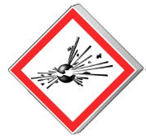 | ☐ Flammable  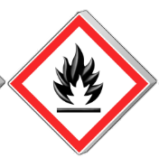 |  |  |  | ☐ Oxidizer  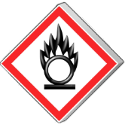
 |  |  | ☐ ABSL1 |  |  | ☐ ABSL2 |  |  |  | ☐ ABSL3
 |  |  | Infectious Agent(s) Present: |  |  | Click or tap here to enter text.
Radiation Hazards |  |  |  |  |  |  |  |  |  |  |  |  | ☐ Gas Cylinder  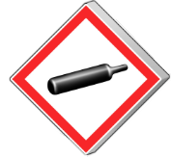 | ☐ Corrosive  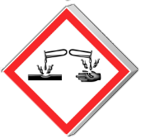 |  |  |  | ☐ Toxic  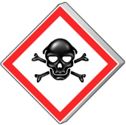
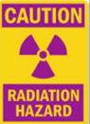 | ☐ Radioactive Materials/Waste  ☐ Microwave  ☐ X-Ray  ☐Transilluminator |  |  |  |  |  |  | Name of Isotope:  Click or tap here to enter text.
Other Hazards |  |  |  |  |  |  |  |  |  |  |  |  | ☐ Harmful   | ☐ Health Hazard  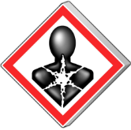 |  |  |  | ☐ Environment  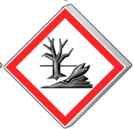
☐ Lasers  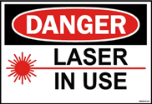 |  |  |  | ☐ Rotating Machinery  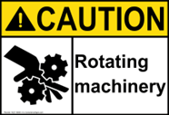 |  |  |  |  | ☐ High Voltage  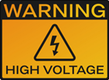
Personal Protective Equipment Required:
☐ Gloves |  | ☐ Coat/Gown |  |  |  |  | ☐ Face Protection  |  |  |  |  | ☐Respirator  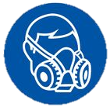 |  |  | ☐ Head Cover  |  |  |  | ☐ Foot Cover 

