PURPOSE
Biological materials and samples occasionally need to be transported between campuses or to off-site
locations by laboratory personnel for educational purposes. Certain biological materials and samples that
are transported by private motor or State-owned vehicles, for the purpose of direct support of their
business (i.e., education) are exempt from most of the Department of Transportation (DOT) hazardous
materials regulations, if the requirements of the Materials of Trade (MOT) exemption are adhered to (see
Appendix C). The University of North Dakota (UND) has instituted this procedure to identify biological
materials and samples that are covered under the MOT exemption and implement actions that need to be
followed when transporting biological materials and samples.

SCOPE
This policy applies to all UND faculty, staff, students, volunteers, space licensees, and contractors.

OVERVIEW
Biological materials and samples transported in personal vehicles must be handled, packaged, and
transported in accordance with all applicable federal, state, local MOT regulations as well as with this
procedure. Biological materials must not be transported on any form of public transportation (e.g., buses,
taxis). Personnel using personal vehicles to transport biological materials should consult with their personal insurance policy regarding liability and coverage in the event of an accident. Incidents/accidents are not covered through UND. This policy does not apply to the relocation or movement of laboratories.

DEFINITIONS
- Division 6.2 Material (49 CFR 173.134 (a)): A material known or reasonably expected to contain a pathogen. A pathogen is a microorganism (including bacteria, viruses, rickettsia, parasites and fungi) or other agents, such as a proteinaceous infectious particle (prion), which can cause disease in humans or animals. A Division 6.2 Material must be assigned to one of the following categories:
- Category A: An infectious substance in a form capable of causing permanent disability or life threatening or fatal disease in otherwise healthy humans or animals when exposure to it occurs (i.e., Yersinia pestis or Ebola virus)
- Biological Substance Category B: An infectious substance that is not in a form generally capable of causing permanent disability or life-threatening or fatal disease in otherwise healthy humans or animals when exposure to it occurs (i.e., Influenza virus or Salmonella).
- Biological product: a virus, therapeutic serum, toxin, antitoxin, vaccine, blood, blood component or derivative applicable to the prevention, treatment, or cure of a disease or condition of human beings or animals.
- Patient specimen: human or animal material collected directly from humans or animals and transported for research, diagnosis, investigational activities, or disease treatment or prevention.
- Materials of Trade (MOT) (49 CFR 173.6): Hazardous materials that are carried on motor vehicles for at least one of the following purposes.
- To protect the health and safety of the motor vehicle operator or passengers, (e.g. insect repellant, fire extinguishers).
- To support the operation or maintenance of motor vehicles/auxiliary. (e.g., engine starting fluid, gasoline, spare battery).
- Materials that must be carried by a private motor carrier to directly support a principal business that is not transportation. (Academic and laboratory research, pest control, plumbing, painting).
- Division 6.2 Material Exceptions (49 CFR 173.134 (b) (10)): A Division 6.2 material, other than a Category A infectious substance, contained in a patient sample being transported for research, diagnosis, investigational activities, or disease treatment or prevention, or a biological product, when such materials are transported by a private or contract carrier in a motor vehicle used exclusively to transport such materials. Medical or clinical equipment and laboratory products may be transported aboard the same vehicle provided they are properly packaged and secured against exposure or contamination.
- MOT Biological Material (49CFR 173.6 (a)(4)): A Division 6.2 material, other than a Category A infectious substance, (i.e., biological substance Category B or patient specimen) contained in human or animal samples (including, but not limited to, secreta, excreta, blood and its components, tissue, and tissue fluids, and body parts) being transported for research, diagnosis, investigational activities, or disease treatment or prevention, or is a biological product or regulated medical waste.

PROCEDURE
- Responsibilities
  - UND faculty, staff, contractors, and/or student workers that transport biological materials must:
- Have a general awareness of the MOT exemptions.
- Complete UND Biological Materials Shipping Training.
- Package, label, and transport shipments materials appropriately.
  - UND Office of Safety
- Identifies personnel that are transporting biological materials.
- Ensures that the MOT exemption is communicated to appropriate personnel (see Appendix C).
- Assists personnel with MOT exemption compliance.
- Transportation of cultures, stocks, or patient specimens
The transportation of biological materials and samples is covered under the MOT exemption and can be transported in a personal vehicle or State owned if the following MOT exemption are met. Category A infectious substances are not allowed to be transported in private motor or State-owned vehicles under the MOT exemptions. These agents are fully regulated by the United States Department of Transportation (DOT) and must be transported by a contracted carrier.
  - Biological materials and samples must be properly packaged and secured against movement and heat exposure using a triple packaging system (see Appendix A):
- Primary leak-proof container(s) (e.g., heat sealed, metal crimped, rubber stopper, secured lid, parafilm or tape).
- Secondary leak-proof container (e.g., wide mouth poly container with lid, zip-lock bag securely closed, or equivalent):
    - For liquids, absorbent material such as loose vermiculite or absorbent material can be used inside the secondary container to absorb liquids.
    - For transporting multiple glass containers, separation of individual primary containers is required.
- Rigid Outer Packaging with adequate strength for its capacity, mass, and intended use (e.g., rigid carboard box, cooler, or 1-to-5-gallon bucket).
- Secondary container must be secured within the outer package with packing material to prevent movement.
- Include an itemized list of package contents between the secondary and outer packaging (see Appendix B).
- Outer container must be labeled with a biohazard label.
  - The personal vehicle used must be “dedicated” to the purpose of transporting the specimens from one campus to the other, not utilized for other purposes at the same time.
  - The driver must be licensed drivers and comply with all applicable driving laws and safety standards (e.g., use of seatbelts).
  - All passengers in the motor vehicle must be informed of the presence of the biological materials being transported.
  - In the event of an emergency or vehicle accident:
  - Call 911 for emergency assistance, if needed.
  - Let all emergency responders know that you are transporting potential biohazards.
  - Notify your supervisor.
  - Arrange for alternate transportation if you are not able to get to your destination.
  - A Biological Spill Kit should be available in the vehicle. Minimally the spill kit should include appropriate gloves, eye protection, absorbent material, and bags for spill debris.
  - When transporting dry ice in a vehicle, the box should not be placed inside the passenger compartment to prevent carbon dioxide accumulation within the vehicle but can be placed in the trunk or open bed of the vehicle.

- Training
Successful completion of the UND Biological Materials Shipping Training must be performed every 2 years.

- Appendices
- Appendix A: Example of Triple Packaging System
- Appendix B: Packing List
- Appendix C: DOT Materials of Trade Brochure (2023)

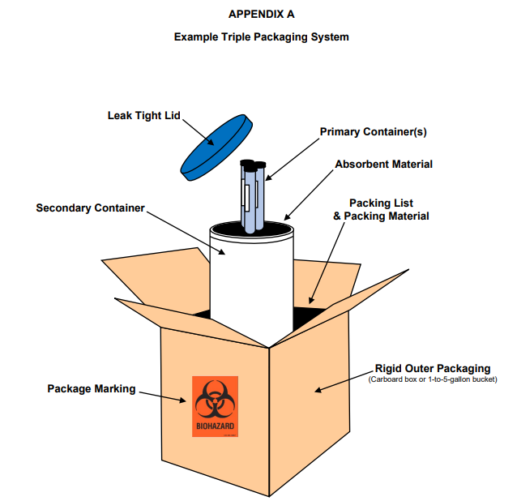

APPENDIX B

PACKING LIST

Date: | Name of Transporter:
Department: | Vehicle License Plate #:
Transported To: | Transported From:
Materials Being Transported |  | Container Type | Quantity
Special Instructions:

APPENDIX C
